**Relating Science to the Society**

In 1991 a hiker in the Alps on the Swiss-Italian border found a well-preserved human body. Although it was first thought to be a person who had recently died, a number of scientific studies over more than a decade concluded the man had lived 53 centuries ago and was about 46 years old when he died. He became known as Ötzi the Iceman. The discovery of the Iceman’s body, the oldest natural human mummy, set off innumerable scientific studies that brought together chemists, biologists, anthropologists, paleontologists, and others from all over the world. Following these studies gives us a marvelous view of how science is done. Among the many discoveries made about the Iceman were the following:  
• Some investigators looked for food residues in the Iceman’s intestines. In addition to finding a few particles of grain, they located tiny flakes of mica believed to come from stones used to grind the grain the man ate. They analyzed these flakes (using argon isotopes) and found their composition was like that of mica in a small area south of the Alps, thus establishing where the man lived in his later years.

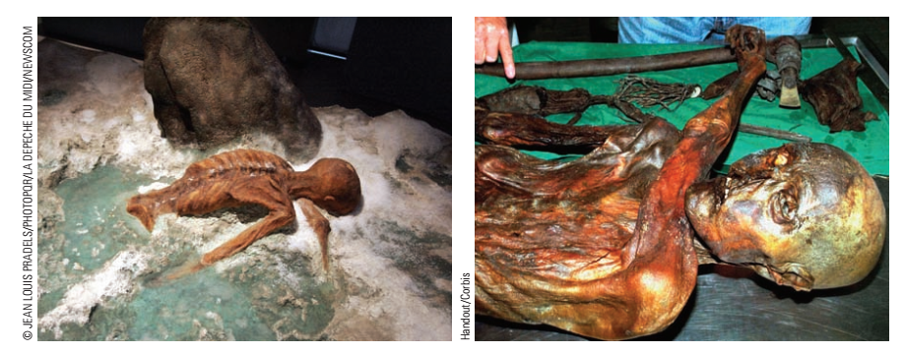

a) The Iceman before the body was removed from the ice b) The body of the Iceman now lies in the Archaeological   
within which he had been frozen for almost 53 centuries. Museum of South Tyrol in Bolzano, Italy.

• High levels of copper and arsenic were found in the Iceman’s hair. These observations, combined with the discovery that his ax was nearly pure copper, led the investigators to conclude he had been involved in copper smelting.  
• One fingernail was still present on his body. Amazingly, scientists could conclude from its appearance that he had been sick three times in the 6 months before he died and his last illness had lasted for 2 weeks.  
• Australian scientists took samples of blood residues from his stone-tipped knife, his arrows, and his coat. Using techniques developed to study ancient DNA, they found the blood came from four different individuals. In fact, the blood on one arrow tip was from two different individuals, suggesting that the man had killed two different people. Perhaps he had killed one person, retrieved the arrow, and used it to kill another.

The many different methods used to reveal the life of the Iceman and his environment are used by scientists around the world, including present-day forensic scientists to study accidents and crimes. As you study chemistry and the chemical principles, keep in mind that many areas of science depend on chemistry and that many different careers in the sciences are available.

**States of Matter and Kinetic-Molecular Theory**

An easily observed property of matter is its **state**—that is, whether a substance is a solid, liquid, or gas. You recognize a material as a solid because it has a rigid shape and a fixed volume that changes little as temperature and pressure change. Like solids, liquids have a fixed volume, but a liquid is fluid—it takes on the shape of its container and has no definite shape of its own. Gases are fluid as well, but the volume of a gas is determined by the size of its container. The volume of a gas varies more than the volume of a liquid with changes in temperature and pressure. At low enough temperatures, virtually all matter is found in the solid state. As the temperature is raised, solids usually melt to form liquids. Eventually, if the temperature is high enough, liquids evaporate to form gases. Volume changes typically accompany changes in state. For a given mass of material, there is usually a small increase in volume on melting—water being a significant exception—and then a large increase in volume occurs upon evaporation.

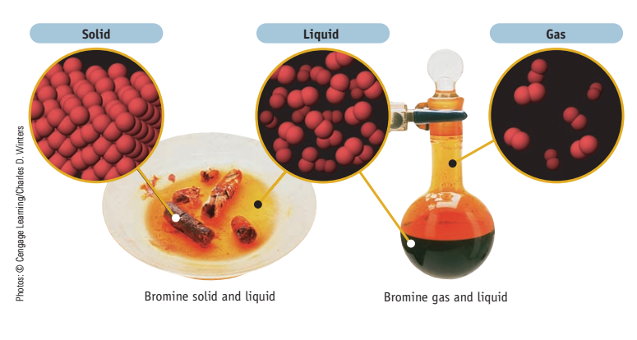

**States of matter—solid, liquid, and gas.** Elemental bromine exists in all three states near room temperature. The tiny  
spheres represent bromine (Br) atoms. In elemental bromine, two Br atoms join to form a Br2 molecule.

The **kinetic-molecular theory of matter** helps us interpret the properties of solids, liquids, and gases. According to this theory, all matter consists of extremely tiny particles (atoms, molecules, or ions) that are in constant motion.  
• In solids these particles are packed closely together, usually in a regular array. The particles vibrate back and forth about their average positions, but seldom do particles in a solid squeeze past their immediate neighbors to come into contact with a new set of particles.  
• The particles in liquids are arranged randomly rather than in the regular patterns found in solids. Liquids and gases are fluid because the particles are not confined to specific locations and can move past one another.  
• Under normal conditions, the particles in a gas are far apart. Gas molecules move extremely rapidly and are not constrained by their neighbors. The molecules of a gas fly about, colliding with one another and with the container walls. This random motion allows gas molecules to fill their container, so the volume of the gas sample is the volume of the container.

An important aspect of the kinetic-molecular theory is that the higher the temperature, the faster the particles move. The energy of motion of the particles (their **kinetic energy**) acts to overcome the forces of attraction between particles. A solid melts to form a liquid when the temperature of the solid is raised to the point at which the particles vibrate fast enough and far enough to push one another out of the way and move out of their regularly spaced positions. As the temperature increases even more, the particles move even faster until finally they can escape the clutches of their comrades and enter the gaseous state.

**Matter at the Macroscopic and Particulate Levels**

The characteristic properties of gases, liquids, and solids are observed by the unaided human senses. They are determined using samples of matter large enough to be seen, measured, and handled. Using such samples, we can determine, for example, what the color of a substance is, whether it dissolves in water, whether it conducts electricity, and if it reacts with oxygen. Observations such as these generally take place in the **macroscopic** world of chemistry. This is the world of experiments and observations.

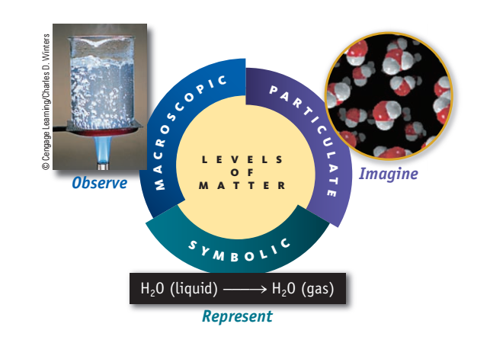

**Levels of matter.** We observe chemical and physical processes at the macroscopic level. To understand or illustrate these processes, scientists often imagine what has occurred at the particulate atomic and molecular levels and write symbols to represent these observations. A beaker of boiling water can be visualized at the particulate level as rapidly moving H2O molecules. The process is symbolized by the chemical equation H2O (liquid) → H2O (gas).

Now let us move to the level of atoms, molecules, and ions—a world of chemistry we cannot see. Take a macroscopic sample of material and divide it, again and again, past the point where the amount of sample can be seen by the naked eye, past the point where it can be seen using an optical microscope. Eventually you reach the level of individual particles that make up all matter, a level that chemists refer to as the **submicroscopic** or **particulate** world of atoms and molecules.

Chemists are interested in the structure of matter at the particulate level. Atoms, molecules, and ions cannot be “seen” in the same way that one views the macroscopic world, but they are no less real. Chemists imagine what atoms must look like and how they might fit together to form molecules. They create models to represent atoms and molecules —where tiny spheres are used to represent atoms—and then use these models to think about chemistry and to explain the observations they have made about the macroscopic world. It has been said that chemists carry out experiments at the macroscopic level, but they think about chemistry at the particulate level. They then write down their observations as “symbols,” the formulas (such as H2O for water or NH3 for ammonia molecules) and drawings that signify the elements and compounds involved. This is a useful perspective that will help you as you study chemistry.

**Pure Substances**

A chemist looks at a glass of drinking water and sees a liquid. This liquid could be the pure chemical compound water. More likely, though, the liquid is a homogeneous mixture of water and dissolved substances—that is, a **solution**. Specifically, we can classify a sample of matter as being either a pure substance or a mixture.

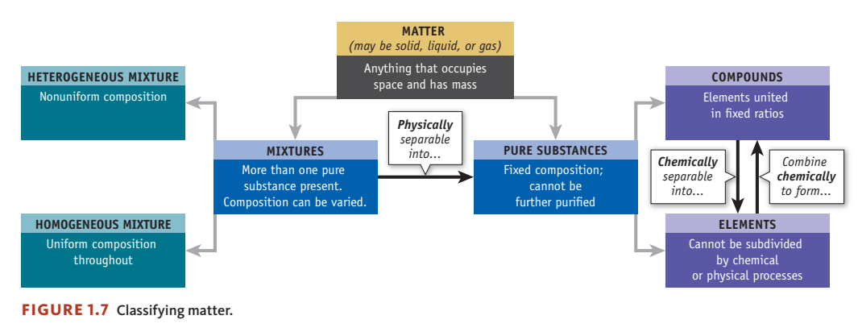

**Classifying matter**

A pure substance has a set of unique properties by which it can be recognized. Pure water, for example, is colorless and odorless. If you want to identify a substance conclusively as water, you would have to examine its properties carefully and compare them against the known properties of pure water. Melting point and boiling point serve the purpose well here. If you could show that the substance melts at 0 °C and boils at   
100°C at atmospheric pressure, you can be certain it is water. No other known substance melts and boils at precisely these temperatures. A second feature of a pure substance is that it cannot be separated into two or more different species by any physical technique at ordinary temperatures. If it could be separated, our sample would be classified as a mixture.

**Mixtures: Homogeneous and Heterogeneous**

A mixture consists of two or more pure substances that can be separated by physical techniques. Sand on the beach is a **heterogeneous** mixture of solids and liquids, a mixture in which the uneven texture of the material can be detected. However, there are heterogeneous mixtures that may appear completely uniform but on closer examination are not. Milk, for example, appears smooth in texture to the unaided eye, but magnification would reveal fat and protein globules within the liquid. In a heterogeneous mixture the properties in one region are different from those in another region. A **homogeneous** mixture consists of two or more substances in the same phase. No amount of optical magnification will reveal a homogeneous mixture to have different properties in different regions. Homogeneous mixtures are often called **solutions**. Common examples include air (mostly a mixture of nitrogen and oxygen gases), gasoline (a mixture of carbon- and hydrogen-containing compounds called *hydrocarbons),* and a soft drink in an unopened container.

When a mixture is separated into its pure components, the components are said to be **purified**. Efforts at separation are often not complete in a single step, however, and repetition almost always gives an increasingly pure substance. For example, soil particles can be separated from water by filtration. When the mixture is passed through a filter, many of the particles are removed. Repeated filtrations will give water a higher and higher state of purity. This purification process uses a property of the mixture, its clarity, to measure the extent of purification. When a perfectly clear sample of water is obtained, all of the soil particles are assumed to have been removed.

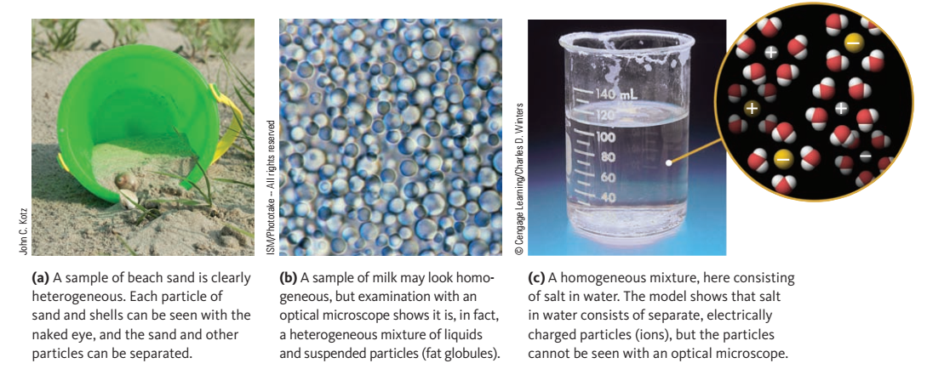

**Heterogeneous and homogenous mixtures**

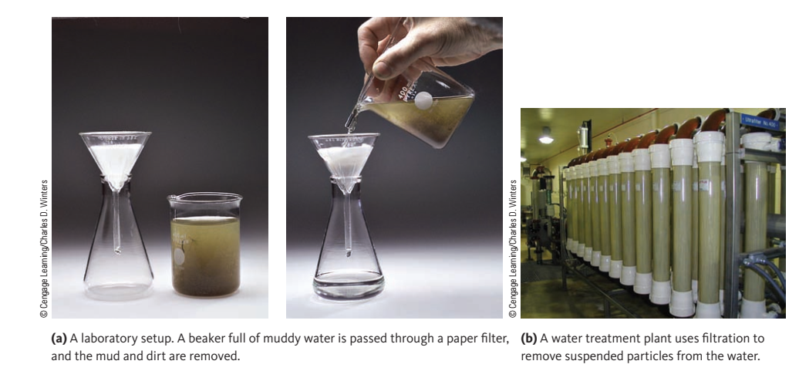

**Purifying a heterogeneous mixture by filtration**

**Elements**

Passing an electric current through water can decompose it to gaseous hydrogen and oxygen. Substances like hydrogen and oxygen that are composed of *only one type of atom* are classified as **elements**. Currently 118 elements are known. Of these, only about 90 are found in nature. The remainder have been created by scientists. Carbon (C), sulfur (S), iron (Fe), copper (Cu), silver (Ag), tin (Sn), gold (Au), mercury (Hg), and lead (Pb) were known to the early Greeks and Romans and to the alchemists of ancient China, the Arab world, and medieval Europe. However, many other elements—such as aluminum (Al), silicon (Si), iodine (I), and helium (He)—were not discovered until the 18th and 19th centuries. Finally, scientists in the 20th and 21st centuries have made elements that do not exist in nature, such as technetium (Tc), plutonium (Pu), and americium (Am). The table below in which the symbol and other information for the elements are enclosed in a box is called the **periodic table**. To see a dynamic periodic table check www.ptable.com. An **atom** is the smallest particle of an element that retains the characteristic chemical properties of that element. Modern chemistry is based on an understanding and exploration of nature at the atomic level.

**Periodic table of elements:**

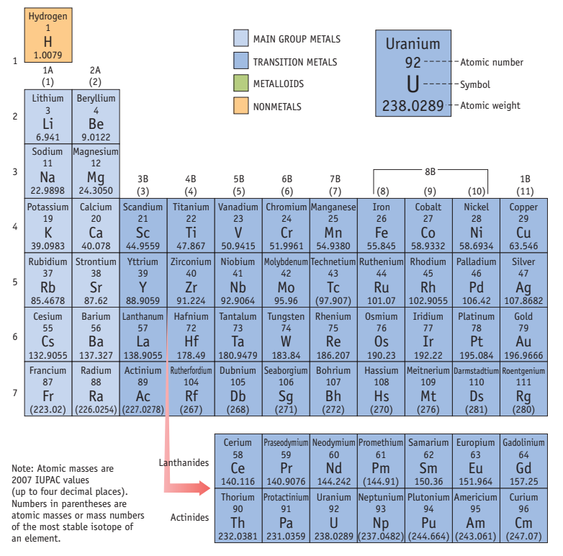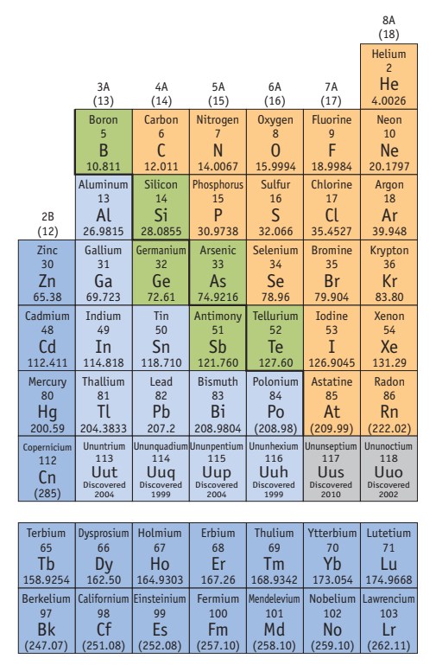

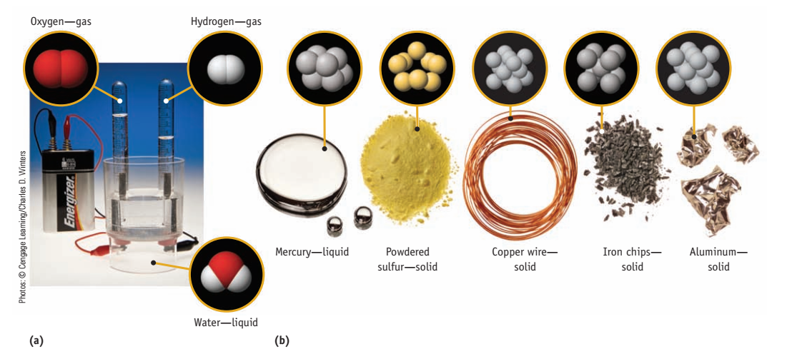

**Elements**. (a) Passing an electric current through water produces the elements hydrogen and oxygen. (b) Chemical elements can often be distinguished by their color and their state at room temperature.

Check the <https://phet.colorado.edu/sims/html/states-of-matter-basics/latest/states-of-matter-basics_en.html> website to see a simulation on the states of matter: Basics.

**Compounds**

A pure substance like sugar, salt, or water, which is composed of two or more different elements held together by **chemical bonds**, is referred to as a **chemical compound**. Even though only 118 elements are known, there appears to be no limit to the number of compounds that can be made from those elements. More than 54 million compounds are now known, with many thousands added to the list each year. When elements become part of a compound, their original properties, such as their color, hardness, and melting point, are replaced by the characteristic properties of the compound. Consider common table salt (sodium chloride), which is composed of two elements:

• Sodium is a shiny metal that reacts violently with water. Its solid state structure has sodium atoms tightly packed together.  
• Chlorine is a light yellow gas that has a distinctive, suffocating odor and is a powerful irritant to lungs and other tissues. The element is composed of Cl2 molecules in which two chlorine atoms are tightly bound together.  
• Sodium chloride, or common salt (NaCl), is a colorless, crystalline solid composed of sodium and chlorine ions bound tightly together. Its properties are completely unlike those of the two elements from which it is made.

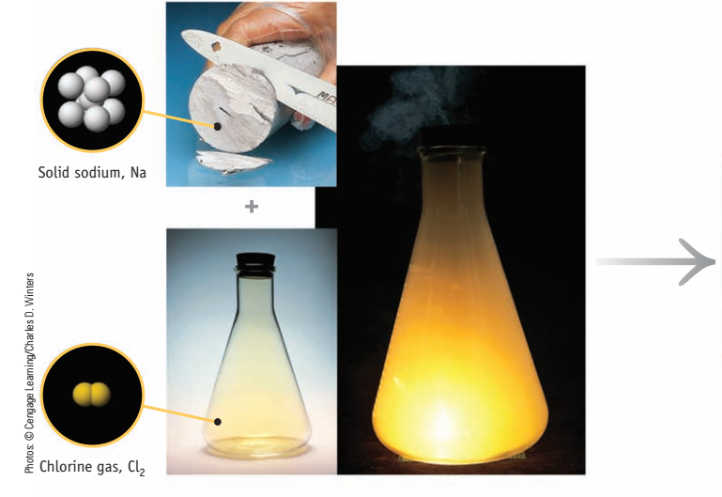 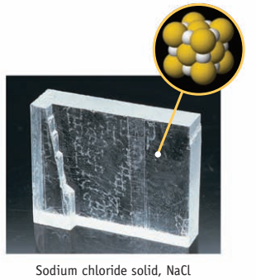

**Forming a chemical compound.** Sodium chloride, table salt, can be made by combining sodium metal (Na) and yellow chlorine gas (Cl2). The result is a crystalline solid, common salt. (The tiny spheres show how the atoms are arranged in the substances. In the case of the salt crystal, the spheres represent electrically charged sodium and chlorine ions.)

It is important to distinguish between a mixture of elements and a chemical compound of two or more elements. Pure metallic iron and yellow, powdered sulfur can be mixed in varying proportions. In the chemical compound iron pyrite, however, there is no variation in composition. Not only does iron pyrite exhibit properties peculiar to itself and different from those of either iron or sulfur, or a mixture of these two elements, but it also has a definite percentage composition by mass (46.55% Fe and 53.45% S). Thus, two major differences exist between a mixture and a pure compound: A compound has distinctly different characteristics from its parent elements, and it has a definite percentage composition (by mass) of its combining elements.

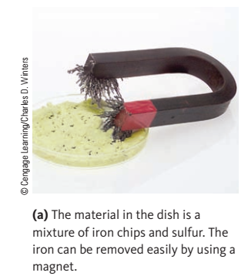 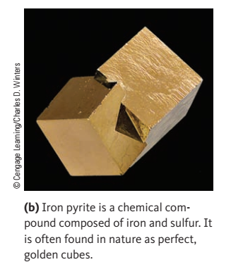

**Mixtures and compounds.**

Some compounds—such as table salt, NaCl—are composed of **ions**, which are electrically charged atoms or groups of atoms. Other compounds— such as water and sugar—consist of **molecules**, the smallest discrete units that retain the composition and chemical characteristics of the compound. The composition of any compound is represented by its **chemical formula**. In the formula for water, H2O, for example, the symbol for hydrogen, H, is followed by a subscript 2, indicating that two atoms of hydrogen occur in a single water molecule. The symbol for oxygen appears without a subscript, indicating that one oxygen atom occurs in the molecule. Figure below illustrates the names, formulas, and models of the structures of a few common molecular compounds.

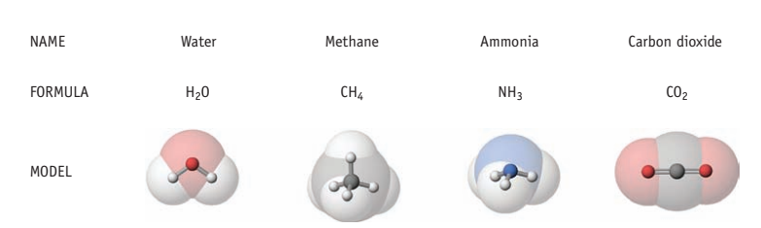

**Names, formulas, and models of some common molecular compounds.** C atoms are gray, H atoms are white, N atom is blue, and O atoms are red.

**Physical Properties**

You recognize your friends by their physical appearance: their height and weight and the color of their eyes and hair. The same is true of chemical substances. You can tell the difference between an ice cube and a cube of lead of the same size not only because of their appearance (one is clear and colorless, and the other is a lustrous metal) but also because one is more dense (lead) than the other (ice). Properties such as these, which can be observed and measured without changing the composition of a substance, are called **physical properties**. The chemical elements clearly differ in terms of their color, appearance, and state (solid, liquid, or gas). Physical properties allow us to classify and identify substances.

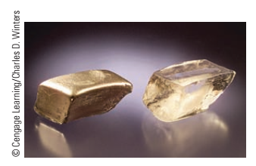

**Physical properties**. An ice cube and a piece of lead can be differentiated   
easily by their physical properties (such as density, color, and melting point).

Table below lists a few physical properties of matter that chemists commonly use.

**Some physical properties:**

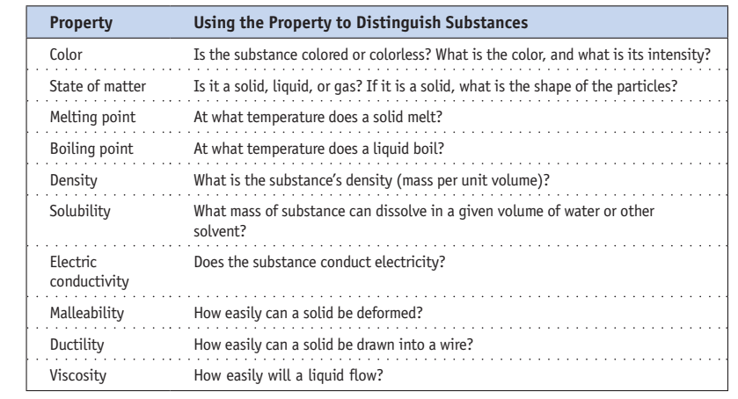

**Density**, the ratio of the mass of an object to its volume, is a physical property useful for identifying substances.

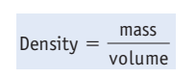

For example, you can readily tell the difference between an ice cube and a cube of lead of identical size because lead has a high density, 11.35 g/cm3 (11.35 grams per cubic centimeter), whereas ice has a density slightly less than 0.917 g/cm3. An ice cube with a volume of 16.0 cm3 has a mass of 14.7 g, whereas a cube of lead with the same volume has a mass of 182 g. The **temperature** of a sample of matter often affects the numerical values of its properties. Density is a particularly important example. Although the change in water density with temperature seems small, it affects our environment profoundly. For example, as the water in a lake cools, the density of the water increases and the denser water sinks. This continues until the water temperature reaches 3.98 °C, the point at which water has its maximum density (0.999973 g/cm3). If the water temperature drops further, the density decreases slightly and the colder water floats on top of water at 3.98 °C. If water is cooled below about 0 °C, solid ice forms. Water is unique among substances in the universe: Its solid form is less dense than its liquid form, so ice floats on water. The volume of a given mass of liquid changes with temperature, so its density does as well. This is the reason laboratory glassware used to measure precise volumes of solutions always specifies the temperature at which it was calibrated.

Simulation on density: https://phet.colorado.edu/sims/density-and-buoyancy/density_en.html

**Temperature Dependence of Water Density**

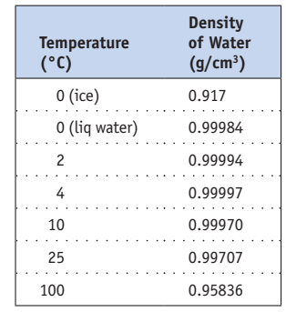

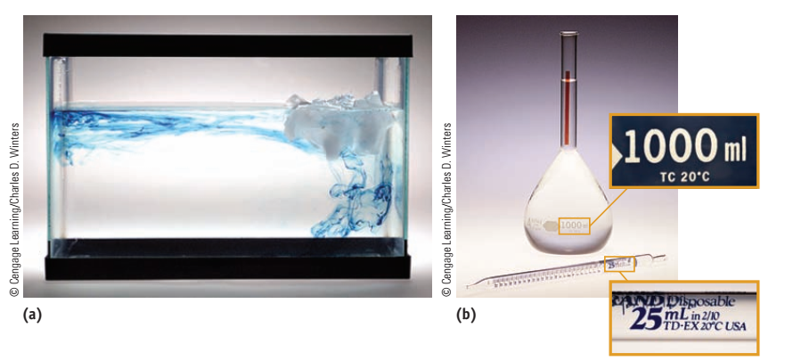

**Temperature dependence of physical properties.** **(a)** *Change in density with temperature.* Ice cubes were placed in the right side of the tank and blue dye in the left side. The water beneath the ice is cooler and denser than the surrounding water, so it sinks. The convection current created by this movement of water is traced by the dye movement as the denser, cooler water sinks. **(b)** *Temperature and calibration.* Laboratory glassware is calibrated for specific temperatures. The pipet will deliver and the volumetric flask will contain the specified volume at the indicated temperature.

Simulation on the boling point: https://lab.concord.org/embeddable.html#interactives/interactions/boiling-point-polar-nonpolar.json

**Extensive and Intensive Properties**

**Extensive properties** depend on the amount of a substance present. The mass and volume of the samples of elements or the amount of energy transferred as heat from burning gasoline, are extensive properties, for example. In contrast, **intensive properties** do *not* depend on the amount of substance. A sample of ice will melt at 0 °C, no matter whether you have an ice cube or an iceberg. The mass and volume of an object are extensive properties because they depend on the amount of sample present. Interestingly, the density of the object, the quotient of mass and volume, is an intensive property. The density of gold, for example, is the same (19.3 g/cm3 at 20 °C) whether you have a flake of pure gold or a solid gold ring. Intensive properties are often useful in identifying a material. For example, the temperature at which a material melts (its melting point) is often so characteristic that it can be used to identify the solid.

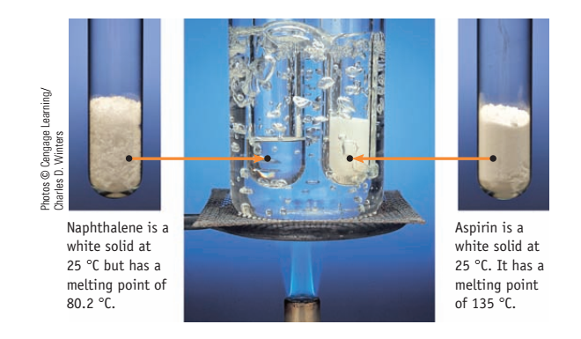

**A physical property used to distinguish compounds.**Aspirin and naphthalene both are white solids at 25 °C. One way to tell them apart is by a difference in physical properties. At the temperature of boiling water, 100 °C, naphthalene is a liquid (left), whereas aspirin is a solid (right).

**Physical and Chemical Changes**

Changes in physical properties are called **physical changes**. In a physical change the identity of a substance is preserved even though it may have changed its physical state or the gross size and shape of its pieces. A physical change does not result in a new chemical substance being produced. The substances (atoms, molecules, or ions) present before and after the change are the same. An example of a physical change is the melting of a solid. In the case of ice melting, the molecules present both before and after the change are H2O molecules. Their chemical identity has not changed; they are now simply able to flow past one another in the liquid state instead of being locked in position in the solid. A physical property of hydrogen gas (H2) is its low density, so a balloon filled with H2 floats in air. Suppose, however, that a lighted candle is brought up to the balloon. When the heat causes the skin of the balloon to rupture, the hydrogen combines with the oxygen (O2) in the air, and the heat of the candle sets off a chemical reaction, producing water, H2O. This reaction is an example of a **chemical change**, in which one or more substances (the **reactants**) are transformed into one or more different substances (the **products**).

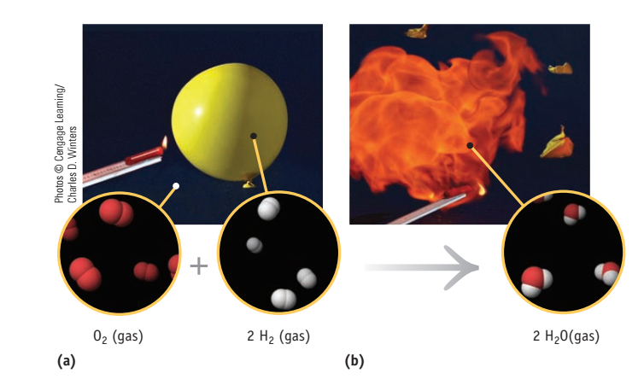

**A chemical change—the reaction of hydrogen and oxygen.** **(a)** A balloon filled with molecules of hydrogen gas and surrounded by molecules of oxygen in the air. (The balloon floats in air because gaseous hydrogen is less dense than air.) **(b)** When ignited with a burning candle, H2 and O2 react to form water, H2O.

A chemical change at the particulate level is illustrated by the reaction of hydrogen and oxygen molecules to form water molecules.

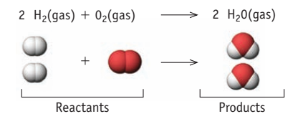

The representation of the change using chemical formulas is called a **chemical equation**. It shows that the substances on the left (the reactants) produce the substances on the right (the products). As this equation shows, there are four atoms of H and two atoms of O before *and* after the reaction, but the molecules before the reaction are different from those after the reaction. A **chemical property** indicates whether and sometimes how readily a material undergoes a chemical change with another material. For example, a chemical property of hydrogen gas is that it reacts vigorously with oxygen gas.

Simulation on the chain reaction of hydrogen and oxygen: https://lab.concord.org/embeddable.html#interactives/interactions/hydrogen-oxygen-chain-reaction.json

Questions:

1. Give the name of each of the following elements:

(a) C (c) Cl (e) Mg

(b) K (d) P (f) Ni

2. Give the symbol for each of the following elements:

(a) barium (c) chromium (e) arsenic

(b) titanium (d) lead (f) zinc

3. In each of the following pairs, decide which is an element and which is a compound.

(a) Na or NaCl

(b) sugar or carbon

(c) gold or gold chloride

4. In each case, decide if the underlined property is a physical or chemical property.

(a) The color of elemental bromine is orange-red.

(b) Iron turns to rust in the presence of air and water.

(c) Hydrogen can explode when ignited in air.

(d) The density of titanium metal is 4.5 g/cm3.

(e) Tin metal melts at 505 K.

(f) Chlorophyll, a plant pigment, is green.

5. Which part of the description of a compound or element refers to its physical properties and which to its chemical properties?

(a) The colorless liquid ethanol burns in air.

(b) The shiny metal aluminum reacts readily with orange-red bromine.

6. A piece of turquoise is a blue-green solid; it has a density of 2.65 g/cm3 and a mass of 2.5 g.

(a) Which of these observations are qualitative and which are quantitative?

(b) Which of the observations are extensive and which are intensive?

(c) What is the volume of the piece of turquoise?

7. The following photo shows the element potassium reacting with water to form the element hydrogen, a gas, and a solution of the compound potassium hydroxide.

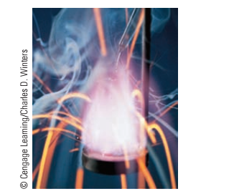

**Potassium reacting with water to produce hydrogen gas and potassium hydroxide.**

(a) What states of matter are involved in the reaction?

(b) Is the observed change chemical or physical?

(c) What are the reactants in this reaction, and what are the products?

(d) What qualitative observations can be made concerning this reaction?

8. Four balloons are each filled with a different gas, each having a different density:

helium (d = 0.164 g/L), neon (d = 0.825 g/L)

argon (d = 1.633 g/L), krypton (d = 4.425 g/L)

If the density of dry air is 1.12 g/L, which balloon or balloons float in air?

9. Small chips of iron are mixed with sand (see photo). Is this a homogeneous or heterogeneous mixture? Suggest a way to separate the iron from the sand.

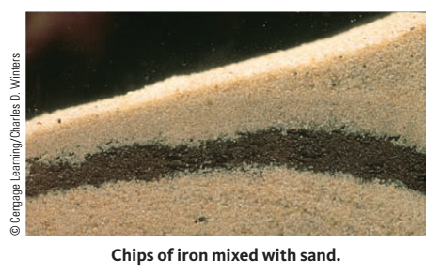

10. The photo below shows elemental iodine dissolving in ethanol to give a solution. Is this a physical or chemical change?

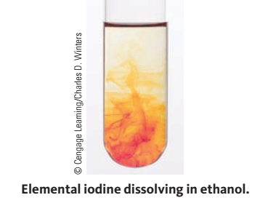

References:

1) John C. Kotz; Paul M. Treichel; John R. Townsend. Chemistry & Chemical Reactivity,Eighth Edition, 2012.

2) https://phet.colorado.edu/

3) https://concord.org